HAVE GOT

Wanneer gebruik ‘have / has got’?
Als je spreekt over een bezit.

Gewone zinnen
Lopen | Walk
Ik heb | I HAVE GOT
Jij hebt | You HAVE GOT
Hij, zij, het heeft | He, she, it HAS GOT
Wij hebben | We HAVE GOT
Jullie hebben | You HAVE GOT
Zij hebben | They HAVE GOT

Ontkennende zinnen (niet = not)
Lopen | Walk
Ik heb niet | I HAVE NOT / HAVEN’T GOT
Jij hebt niet | You HAVE NOT / HAVEN’T GOT
Hij, zij, het heeft niet | He, she, it HAS NOT / HASN’T GOT
Wij hebben niet | We HAVE NOT GOT
Jullie hebben niet | You HAVE NOT / HAVEN’T GOT
Zij hebben niet  ? | They HAVE NOT / HAVEN’T GOT

Vragende zinnen
Lopen | Walk
Heb ik …..? | HAVE I …..?
Heb jij …..? | HAVE you …..?
Is hij, zij, het heeft …..? | HAS he, she, it …..?
Hebben wij …..? | HAVE we …..?
Hebben jullie …..? | HAVE you …..?
Hebben zij …..? | HAVE they …..?

Opdracht 1 gewone zinnen
- She …………………………………. two cars.
- My best friends …………………………………. nice house.
- My parents …………………………………. two children.
- I …………………………………. a swimming pool.
- My cat …………………………………. a great costume for carnival.
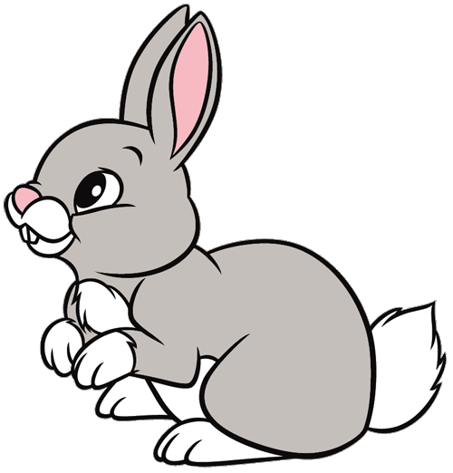
- The three sisters all …………………………………. red hair.
- You …………………………………. nice parents.
- Stan …………………………………. a rabbit.
- We …………………………………. a lot of homework.
- My daughter Isabeau …………………………………. a lot of fun.

Opdracht 2 ontkennende zinnen
- Mr Trump …………………………………. a lot of friends.
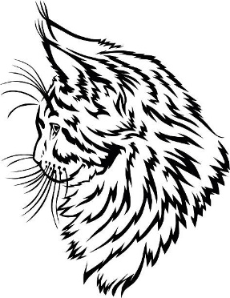
- My house…………………………………. 5 doors.
- I …………………………………. a blue car.
- We …………………………………. two big Maine Coons but three.
- Your school …………………………………. a swimming pool.
- Our king and queen …………………………………. three sons.
- They …………………………………. a castle.
- I …………………………………. a new bicycle.
- You …………………………………. the flu.
- Tom …………………………………. a vampire at home.

Opdracht 3 vraagzinnen
- ……………….. Mohammed ……………….. a sister?
- ……………….. Stijn and Rafke ……………….. a vampire?
- ……………….. I ……………….. an Apple watch?
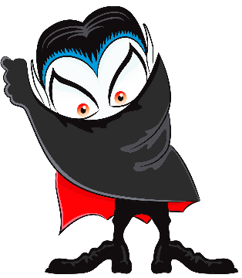
- ……………….. you ……………….. some chocolate for us?
- ……………….. we ……………….. English or Dutch?
- ……………….. Mrs Van Lierop ……………….. teddy bear at home?
- ……………….. they ……………….. something to drink for me?
- ……………….. you ……………….. time for me?
- ……………….. Tijn ……………….. glasses?
- ……………….. I ……………….. the same haircut as Mr Trump?

